Solid Angle
# Source: AI Source: Provided by: [Data Path: Persons Table -> ID Column: 1, Name_En Column: Motasem Essam] -> From: [ChatGPT] on [7/25/2026]
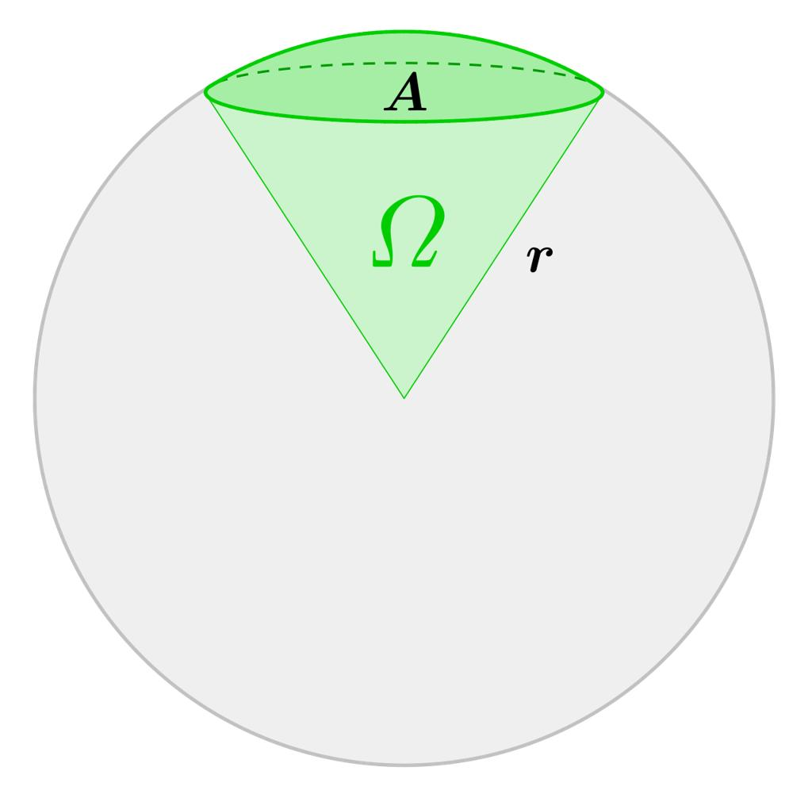
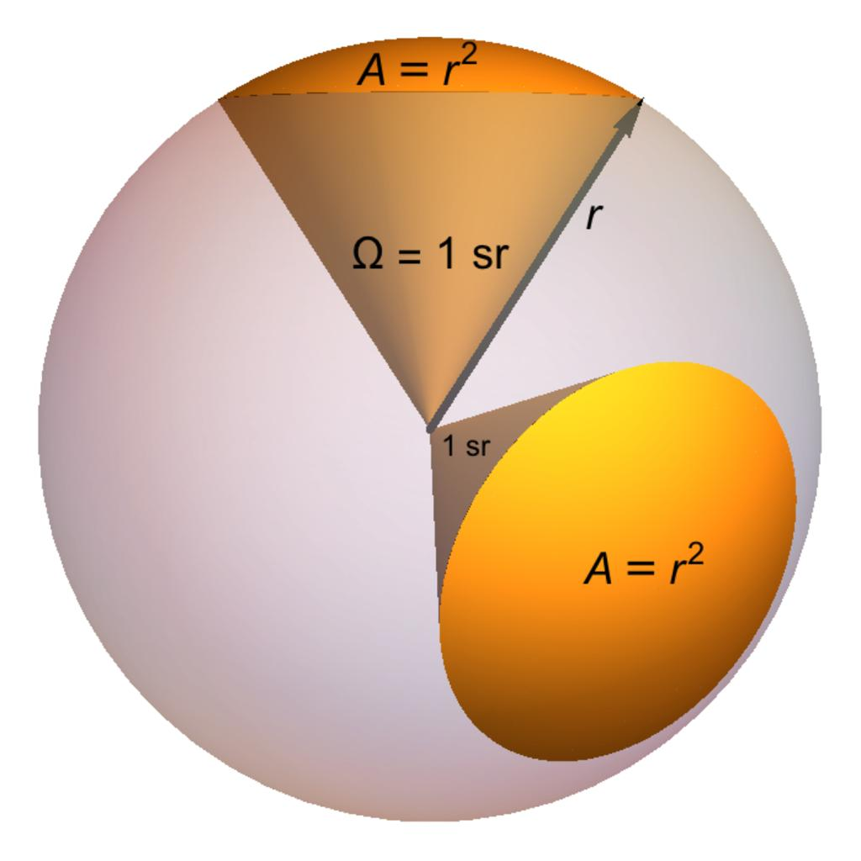
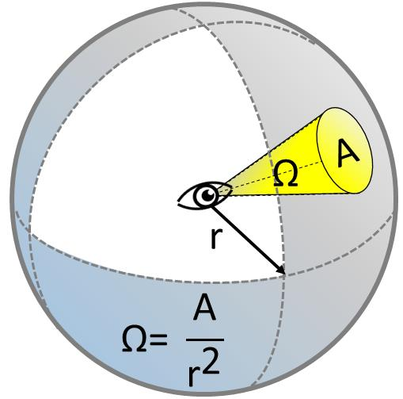

Definition
# Source: AI Source: Provided by: [Data Path: Persons Table -> ID Column: 1, Name_En Column: Motasem Essam] -> From: [ChatGPT] on [7/25/2026]
A solid angle is a three-dimensional measure of how large an object or region appears from a particular point. It describes the spread of a set of rays extending from a common vertex and passing through a region in space.
The vertex is called the apex of the solid angle. Its boundary may be formed by several surfaces, and the region it covers can be visualized as a three-dimensional cone.
The solid angle is measured in steradians, symbolized by $\text{sr}$.
For example, a small distant object generally subtends a smaller solid angle than a nearby object of the same size.

Simple Definition
# Source: AI Source: Provided by: [Data Path: Persons Table -> ID Column: 1, Name_En Column: Motasem Essam] -> From: [ChatGPT] on [7/25/2026]
A solid angle is the three-dimensional equivalent of an ordinary plane angle.
- A plane angle measures how widely two rays spread apart in a flat plane.
- A solid angle measures how widely a collection of rays spreads out in three-dimensional space.
Imagine standing at the center of a room and looking at a small lamp. The lamp occupies a certain portion of your field of view. That portion corresponds to the solid angle subtended by the lamp at your eye.

3. Classification Tree
# Source: AI Source: Provided by: [Data Path: Persons Table -> ID Column: 1, Name_En Column: Motasem Essam] -> From: [ChatGPT] on [7/25/2026]
Mathematics
Geometry
Euclidean Geometry
Solid Geometry
Types of Angles in Solid Geometry
Solid Angle
Solid angle subtended by a surface
Solid angle of a circular cone
Solid angle of a hemisphere
Solid angle of a full sphere
These are common geometric situations involving solid angles rather than mutually exclusive angle types. A solid angle can have many different shapes and sizes.

Key Characteristics
# Source: AI Source: Provided by: [Data Path: Persons Table -> ID Column: 1, Name_En Column: Motasem Essam] -> From: [ChatGPT] on [7/25/2026]
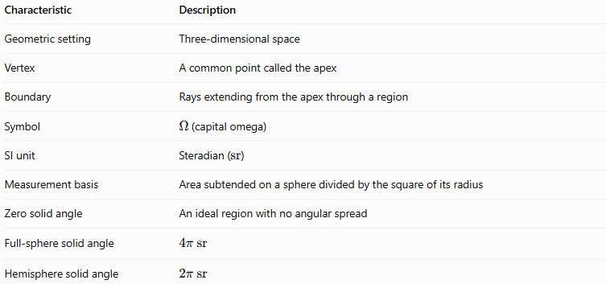
Characteristic | Description
Geometric setting | Three-dimensional space
Vertex | A common point called the apex
Boundary | Rays extending from the apex through a region
Symbol | $Ω$ (capital omega)
SI unit | Steradian ($\text{sr}$)
Measurement basis | Area subtended on a sphere divided by the square of its radius
Zero solid angle | An ideal region with no angular spread
Full-sphere solid angle | $$4π\text{ s}\text{r}$$
Hemisphere solid angle | $$2π\text{ s}\text{r}$$

Geometric Representation
# Source: AI Source: Provided by: [Data Path: Persons Table -> ID Column: 1, Name_En Column: Motasem Essam] -> From: [ChatGPT] on [7/25/2026]
Imagine a sphere centered at the apex $O$. A group of rays from $O$ passes through a patch of the sphere's surface, enclosing a cone-shaped region.
The solid angle depends on the area $A$ of the spherical patch and the sphere's radius $r$.
Schematic: rays from apex $O$ enclose a region on a sphere. The spherical patch area $A$ determines the solid angle for radius $r$.
The spherical surface is a convenient way to measure a solid angle. The same group of rays intersects spheres of different radii in patches of different areas, but the ratio $A/r^{2}$ remains constant.

Mathematical Representation and Formulas

A. Solid angle from spherical surface area
# Source: AI Source: Provided by: [Data Path: Persons Table -> ID Column: 1, Name_En Column: Motasem Essam] -> From: [ChatGPT] on [7/25/2026]
The fundamental formula is
$$\boxed{Ω=\frac{A}{r^{2}}}$$
where:
- $Ω$ is the solid angle in steradians.
- $A$ is the area of the spherical patch intercepted by the rays.
- $r$ is the radius of the sphere centered at the apex.
The formula is exact when $A$ is measured on the sphere's surface, not on a flat plane.
Since a sphere's total surface area is $4πr^{2}$, the solid angle around a point in all directions is
$$Ω_{\text{sphere}}=\frac{4πr^{2}}{r^{2}}=\boxed{4π\text{ sr}}.$$

B. Solid angle of a circular cone
# Source: AI Source: Provided by: [Data Path: Persons Table -> ID Column: 1, Name_En Column: Motasem Essam] -> From: [ChatGPT] on [7/25/2026]
For a right circular cone with apex half-angle $α$, the solid angle is
$$\boxed{Ω=2π\left(1-\cos{α}\right)}$$
Here, $α$ is measured between the cone's central axis and its sloping side.
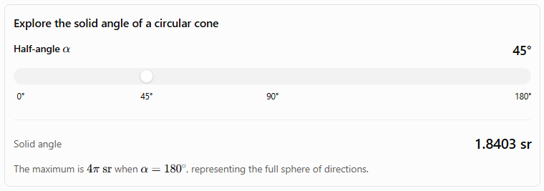
Explore the solid angle of a circular cone
Half-angle $α$
45°
0°
45°
90°
180°
Solid angle
1.8403 sr
The maximum is $4π\text{ sr}$ when $α={180}^{∘}$, representing the full sphere of directions.
For example, when $α={60}^{∘}$,
$$\begin{aligned}Ω&=2π\left(1-{\cos{60}}^{∘}\right) \\ &=2π\left(1-\frac{1}{2})\right. \\ &=\boxed{π\text{ sr}}.\end{aligned}$$

C. Common solid angles
# Source: AI Source: Provided by: [Data Path: Persons Table -> ID Column: 1, Name_En Column: Motasem Essam] -> From: [ChatGPT] on [7/25/2026]
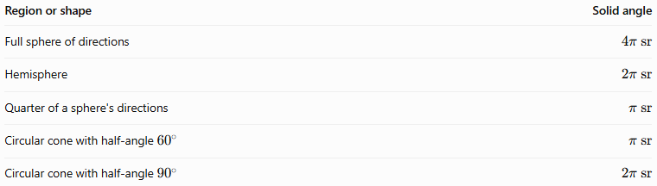
Region or shape | Solid angle
Full sphere of directions | $$4π\text{ s}\text{r}$$
Hemisphere | $$2π\text{ s}\text{r}$$
Quarter of a sphere's directions | $$π\text{ s}\text{r}$$
Circular cone with half-angle ${60}^{∘}$ | $$π\text{ s}\text{r}$$
Circular cone with half-angle ${90}^{∘}$ | $$2π\text{ s}\text{r}$$
These values assume the indicated regions are centered at the same apex. The quarter-sphere value applies to a region occupying one-quarter of the full sphere's directions.

D. Solid angle of a small flat surface
# Source: AI Source: Provided by: [Data Path: Persons Table -> ID Column: 1, Name_En Column: Motasem Essam] -> From: [ChatGPT] on [7/25/2026]
For a small flat area $S$, viewed from a point at distance $r$, the approximate solid angle is
$$\boxed{Ω≈\frac{S\cos{β}}{r^{2}}}$$
where $β$ is the angle between the surface's normal and the direction toward the viewing point.
This approximation is useful when the surface is small compared with its distance from the apex. For a large or nearby surface, the solid angle should be calculated using its full geometry.

Worked Examples
# Source: AI Source: Provided by: [Data Path: Persons Table -> ID Column: 1, Name_En Column: Motasem Essam] -> From: [ChatGPT] on [7/25/2026]
Example 1: Solid angle from spherical area
A spherical patch has an area of $8{\text{ m}}^{2}$ on a sphere of radius $4\text{ m}$. Find the solid angle.
Given:
$$A=8{\text{ m}}^{2}, r=4\text{ m}.$$
Apply the formula:
$$Ω=\frac{A}{r^{2}}=\frac{8}{4^{2}}=\frac{8}{16}.$$
Answer:
$$\boxed{Ω=0.5\text{ sr}}$$
Example 2: Solid angle of a hemisphere
A hemisphere covers half of the full sphere of directions.
Since a full sphere subtends $4π\text{ sr}$,
$$Ω=\frac{12}{\left(4π\right)}.$$
Answer:
$$\boxed{Ω=2π\text{ sr}}$$
Approximately,
$$Ω≈6.2832\text{ sr}.$$
Example 3: Solid angle of a circular cone
A cone has a half-angle of ${30}^{∘}$. Find its solid angle.
Use
$$Ω=2π\left(1-\cos{α}\right).$$
Substitute $α={30}^{∘}$:
$$Ω=2π\left(1-{\cos{30}}^{∘}\right).$$
Since ${\cos{30}}^{∘}=\frac{\sqrt{3}}{2}$,
$$\boxed{Ω=2π\left(1-\frac{\sqrt{3}}{2}\right)}$$
Numerically,
$$\boxed{Ω≈0.8418\text{ sr}}.$$
Example 4: Solid angle of a full sphere
A sphere has radius $r=5\text{ m}$. Find the solid angle covering all directions from its center.
Its surface area is
$$A=4πr^{2}=4π\left(25\right)=100π{\text{ m}}^{2.}$$
Then
$$Ω=\frac{100π}{25}.$$
Answer:
$$\boxed{Ω=4π\text{ sr}≈12.5664\text{ sr}}$$
The result does not depend on the sphere's radius.

Comparison With Related Concepts
# Source: AI Source: Provided by: [Data Path: Persons Table -> ID Column: 1, Name_En Column: Motasem Essam] -> From: [ChatGPT] on [7/25/2026]
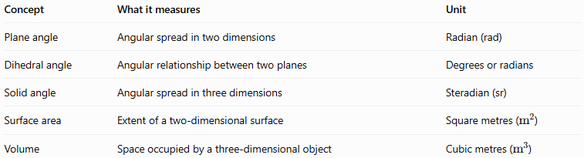
Concept | What it measures | Unit
Plane angle | Angular spread in two dimensions | Radian (rad)
Dihedral angle | Angular relationship between two planes | Degrees or radians
Solid angle | Angular spread in three dimensions | Steradian (sr)
Surface area | Extent of a two-dimensional surface | Square metres (${\text{m}}^{2}$)
Volume | Space occupied by a three-dimensional object | Cubic metres (${\text{m}}^{3}$)
A solid angle is dimensionless in the SI system because it is a ratio of area to squared length. The steradian is nevertheless used to identify the physical quantity being measured.
For comparison:
- A plane angle can be measured using the ratio of arc length to radius.
- A solid angle can be measured using the ratio of spherical surface area to radius squared.

Applications
# Source: AI Source: Provided by: [Data Path: Persons Table -> ID Column: 1, Name_En Column: Motasem Essam] -> From: [ChatGPT] on [7/25/2026]
Solid angles are important in several scientific and practical fields:
- Optics: describing the portion of space occupied by a light source as viewed from a point.
- Astronomy: measuring the apparent extent of the Sun, Moon, stars, and other celestial objects.
- Radiometry: calculating radiant intensity and the distribution of light or other electromagnetic radiation.
- Photography and cameras: understanding fields of view and how much of a scene a sensor captures.
- Physics: describing directional distributions of particles and radiation.
- Computer graphics: representing viewing regions, light sources, and visibility in three-dimensional scenes.

Key Points
# Source: AI Source: Provided by: [Data Path: Persons Table -> ID Column: 1, Name_En Column: Motasem Essam] -> From: [ChatGPT] on [7/25/2026]
- A solid angle measures angular spread in three-dimensional space.
- Its vertex is called the apex.
- Its SI unit is the steradian ($\text{sr}$).
- The fundamental formula is $Ω=A/r^{2}$, where $A$ is spherical surface area.
- A full sphere covers $4π\text{ sr}$; a hemisphere covers $2π\text{ sr}$.
- For a circular cone, $Ω=2π\left(1-\cos{α}\right)$, where $α$ is the cone's half-angle.
- Solid angle is the three-dimensional analogue of a plane angle.

Conclusion
# Source: AI Source: Provided by: [Data Path: Persons Table -> ID Column: 1, Name_En Column: Motasem Essam] -> From: [ChatGPT] on [7/25/2026]
The solid angle describes how much of the surrounding three-dimensional space is covered by rays spreading from a common point. Unlike a plane angle, which measures spread in a flat plane, a solid angle measures spread over a spherical region and is expressed in steradians.
It is a fundamental concept in solid geometry and has important applications in optics, astronomy, radiation measurement, and computer graphics.

